**Practical-2**

**Basic Commands:**

1)system administrator : passwd

**→**The passwd command changes passwords for user accounts. A normal user may only change the password for their own account, while the superuser may change the password for any account.

2) Help: man

→man command in Linux is used to display the user manual of any command that we can run on the terminal. It provides a detailed view of the command which includes NAME, SYNOPSIS, DESCRIPTION, OPTIONS, EXIT STATUS, RETURN VALUES, ERRORS, FILES, VERSIONS, EXAMPLES, AUTHORS and SEE ALSO.

3)Directory: mkdir

→The mkdir stands for 'make directory'. With the help of mkdir command, you can create a new directory wherever you want in your system. Just type "mkdir<dir name> , in place of <dir name> type the name of the new directory you want to create and then press enter.

4)Editor: vi

→Vi editor is a powerful and widely used text editor in UNIX and Linux operating system. It allows us to create, edit and manage text files. Vim is the advanced version of vi editor. There are three modes in vi: Command mode, Last Line Mode and Insert Mode.

5)File Handling / Text Processing: cp

The Linux cp command. You use the cp command in Linux to copy files and directories from one location to another.

6)Security and Protection: chmod

→The `chmod` command in Linux is used to modify the permissions and access mode of files and directories. These are the permissions that control who can read, write and execute the file. We have discussed two types of modes for specifying permission: symbolic and octal mode.

7)Information: man

→man command in Linux is used to display the user manual of any command that we can run on the terminal.

8)Terminal: echo

→echo command in linux is used to display lines of text/string that are passed as an argument . This is a built-in command that is mostly used in shell scripts and batch files to output status text to the screen or a file. In the above example, text after \c is not printed and omitted trailing new line.

9)Process: ps

→The ps command, short for Process Status, is a command line utility that is used to display or view information related to the processes running in a Linux system.

10)kill:

→The kill command sends a signal to a process. This can terminate a process (the default), interrupt it, suspend it, crash it, and so on.

**Aim:**

**1.Create two directories with dir1 and dir2 names which contain a file in them. file1**

**in dir1 should contain country names and file2 in dir2 should contain capital**

**names. display the content as given below:**

**. List first 5 names of country**

**a. Display content of file1 and file2 such that against each country name, there**

**should be its capital name.**

**b. Keep only first 3 letters of all country name and save it to new file named**

**initials.txt**

**Theoretical Background:**

**mkdir** is a command that creates a new directory.

Syntax:mkdirdirectory_name

**echo** is a command that prints text to the terminal.

Syntax:echo text

**cat** is a command that reads the contents of a file and prints it to the terminal.

Syntax: cat file_name

**head** is the command that used to display the content of the file.

Syntax : head -n number_of_linesfile_path

**paste**is a command for the display of contents of two files in two different directories.

Syntax : paste file_path1 file_path2

**Source Code:**

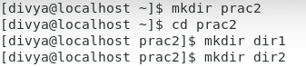

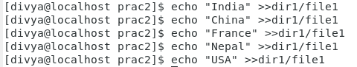

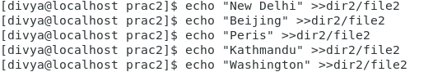

**Output:**

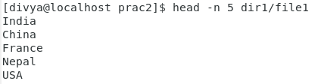

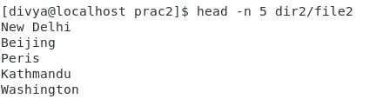

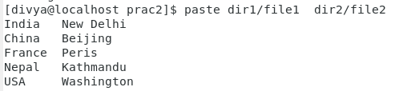

**Learning Outcome:**

In this task I learned different commands and their uses in LINUX.

Some of commands were mkdir,catetc.

**Aim:**

**2. Create a file with marks of students. Display the file content according to the**

**descending order of the student's marks.**

**Theoretical Background:**

The command "sort -n <file_name>" is used in Linux to sort the contents of a file in numerical order.

-Syntax: sort -n <file_name>

sort: Command to sort lines of text.

-n: Option to specify numerical sorting.

<file_name>: The name of the file you want to sort.

**Source Code:**

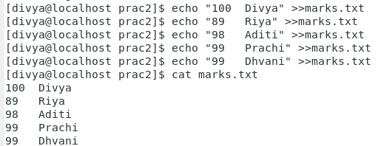

**Output:**

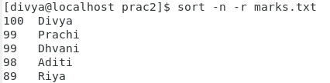

**Learning Outcome:**

In this task I learned different commands and their uses in LINUX. Using those commands I learned how to sort the data using sort command.

**Aim:**

**3. Using command search for the valid email address and mobile number from the**

**given student data file.**

**Theoretical Background:**

The "grep" command is used in Linux to search for a specific pattern or regular expression in files.

General syntax: grep <pattern><file_name>

grep: Command for searching text.

<pattern>: The pattern or regular expression to search for.

<file_name>: The name of the file or files to search within. It can be a single file or multiple

files separated by spaces.

**Source Code:**

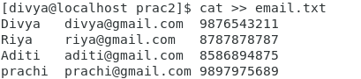

**Output:**

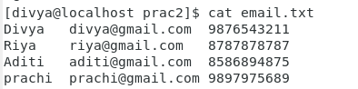

**Learning Outcome:**

In this task I learned different commands and their uses in LINUX. Learned how to validate using grep command in email.

**Aim:**

**4. Using Linux command, add five star (*****) at the beginning of each line and**

**delete all blank lines.**

**Theoretical Background:**

-The sed command in Linux is used for stream editing and manipulating text. It reads input line by line, applies specified operations, and outputs the modified text.

-Syntax :sed [options] 'command' file_name

**sed**: The command itself that invokes the stream editor.

**[options]**: Additional flags or options that modify the behavior of the **sed** command.

**'command'**: The operation or set of commands enclosed in single quotes, specifying how the text should be modified.

**file**: The input file on which the **sed** command operates. If omitted, **sed** reads from standard input (e.g., piped input or keyboard input).

-Note that the **sed** command supports a wide range of commands and options, allowing you to perform various text transformations like search and replace, insertion, deletion, and more.

**Source Code:**



**Output:**

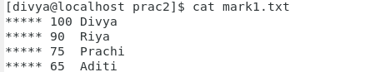

**Learning Outcome:**

In this task I learned sed commands and their uses in LINUX. Learned how to efficiently manipulate and transform text files using editing techniques.

Grade:

Sign: